Name:_____________________________
Evolution
Offspring =
Mate =
Fertile =
Ancestors =
Generation =

Species =
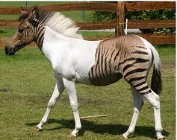
For example male horses can mate with female horses to produce young horses (offspring). These young horses can grow up to mate and have their own offspring. So horses are in the same ______________.
A Zebra and a Horse can mate to produce a Zeedonk. A Zeedonk cannot reproduce, it is ___________. A Zebra and horse are not in the same ____________.

Example | Same species? Yes or no.
A horse and a donkey can mate to give an offspring called a Mule. Mules are not fertile. Mules cannot reproduce.
Poodle dog and German Shepard dog can mate to give offspring. The offspring are fertile and can grow up to have offspring of their own.
A lion and a tiger can reproduce to give a Liger. A Liger is not fertile. It cannot reproduce.

Evolution =

For examples the horses we see today evolved from a much smaller animal. This took millions of years to happen.
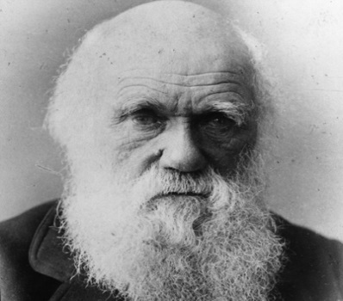
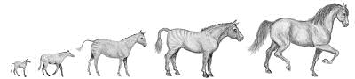

The idea of evolution is credited to Charles Darwin.
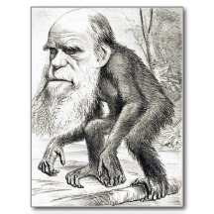
Not everyone agrees with his theory. Here is a cartoon that was drawn of him, at the time his theory was released.

What was this cartoon trying to say?

You do not need to believe evolution formed the plants and animals (including humans) that we see today, but you should understand the idea.
Evidence for Evolution
- Fossils. By looking at fossils it is possible to see the gradual change in species over time. Fossils are
Here we can see the fossil record of horse skulls. What changes can you see occurring over time?
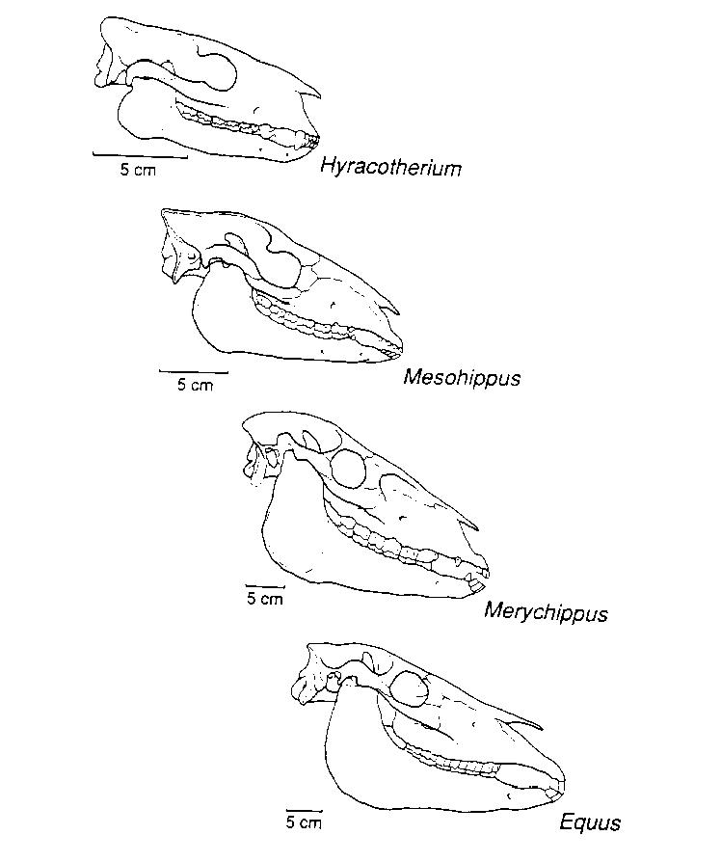
- Genetics =

- Homologous structures=
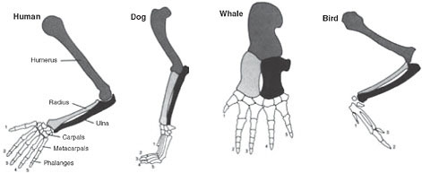
Count how many finger the human hand has ________. Now count the number of finger like bones in the flipper of the Whale = _____. The idea is that they both come from a common ancestor that had 5 “finger” bones.

Key words
Match the word with the correct definition

Mate
Species
Fertile
Generation
Ancestors
Fossil
Offspring
Evolution
Fossils

Word | Meaning(definition)
 | the children
 | able to mate and produce offspring
 | the relatives of a person that lived before them
 | the time between the birth of one animal and the time when that animal produces its own offspring
 | To have sexual intercourse
 | one type of living thing with shared characteristics. Members of the same species are able to mate with other members of that species and produce fertile offspring
 | the change in a species over many generations resulting in new species being made
 | the remains (or an impression) of a plant or animal that existed in a past geological age and that has been excavated from the soil
 | the of a plant or animal that existed in a past has been dug out of the ground

